**CIS4560 TERM PROJECT**

**Authors: Javier Nava, Oscar Munoz, Jesse Fabian, Ky Hoang**

**Instructor:** [**Jongwook Woo**](https://www.linkedin.com/in/jongwook-woo-7081a85)

**Date: 12/3/2018**

**Lab Tutorial:**

**ANALYZING NEW YORK’S PARKING TICKETS USING HADOOP, APACHE PIG, AND POWER BI**

**Objectives**

In this hands-on-lab, students will:

* Download the data
* Upload data files
* Load data files into Apache Pig
* Filter data in Pig
* Store data into hdfs file
* Use Power BI to Visualize data

**Platform Spec**

* Oracle Big Data
* Cluster Version: 2.7.1
* Cluster number of nodes: 5 nodes
* OCPUs: 10
* Memory size: 150 GB
* Storage: 678 GB
* HDFS Capacity: 147 GB
* CPU speed: 2195 MHz

Commands for Cluster Versions and CPU speed are as followed:

$ hdfs version

…

$ lscpu | grep MHz

Step 1: Download the data

You need to download the zip file from the following link: <https://s3-us-west-1.amazonaws.com/omunoz7/nyc-parking-tickets-2017.zip> . From the shell terminal, download the “NYC 2017’s parking tickets” zip file by following the command below:

$ wget <https://s3-us-west-1.amazonaws.com/omunoz7/nyc-parking-tickets-2017.zip>

Output should look like:

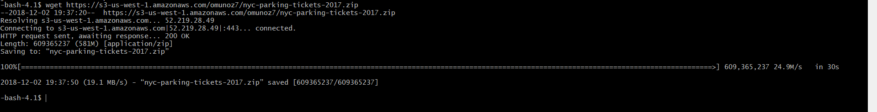

Step 2: Unzip and upload the data files

After you have successfully download the file, unzip the file to get the csv data file. Remove the zip file in the home directory to free up storage. Use the “ls” command to confirm that the zip file is removed and the unzipped file is present. Create a new directory called “parking” in Hadoop Distributed File System, then move the unzipped csv file to the new directory using the “-put” command. Follow the commands below:

$ unzip nyc-parking-tickets.zip

$ rm nyc-parking-tickets.zip

$ ls

$ hdfs dfs -mkdir parking

$ hdfs dfs -put Parking_Violations_Issued_-_Fiscal_Year_2017.csv ./parking/

$ hdfs dfs -mv ./parking/Parking_Violations_Issued_-_Fiscal_Year_2017.csv./parking/tickets.csv

$ hdfs dfs -ls

Found 4 items  
drwxr-xr-x - khoang21 hdfs 0 2018-11-07 22:05 .hiveJars  
drwx------ - khoang21 hdfs 0 2018-11-28 22:35 .staging  
drwxr-xr-x - khoang21 hdfs 0 2018-11-28 21:40 dualcore  
**drwxr-xr-x - khoang21 hdfs 0 2018-12-03 00:15 parking**

Check that the file is moved to the directory. There should be an item found. To check that the data file is correct, you can display the first 20 records of the data set by using the “-cat” command. Follow the steps by using the commands below:

$ hdfs dfs -ls parking

Found 1 items

-rw-r--r-- 2 khoang21 hdfs 2086913576 2018-12-03 00:12 parking/tickets.csv

$ hdfs dfs -cat ./parking/tickets.csv | head -20

Results should look like the following:

…

…

1413656420,T672371C,NY,PAS,02/04/2017,40,TAXI,TOYOT,P,59630,73470,82230,20170531,0073,73,73,960758,0073,0000,0525A,,K,F,279,MCDOUGAL ST,,0,408,F1,,BBBBBBB,ALL,ALL,BLK,0,2015,-,0,,,,,

7959486440,GYF2052,NY,PAS,07/07/2016,71,4DSD,VOLKS,T,70407,17390,48890,20170527,120,120,120,356557,T303,E,0645P,,R,F,143,N St Austins Pl,,0,408,j6,,,,,GY,,2012,,0,C-PM,71-Insp. Sticker Missing (NYS,,,

5093620865,AD80228,AZ,PAS,09/24/2016,7,TK,FORD,V,0,0,0,0,,0,0,0,,,1122A,,QN,,,SO CONDUIT AVE (E/B),@ 89TH ST,0,1111,D,T,,,,,,2009,,0,,FAILURE TO STOP AT RED LIGHT,,,

8480309064,51771JW,NY,COM,01/26/2017,64,VAN,INTER,T,17850,10210,10110,88888888,0017,17,17,363557,T102,L,0256P,,NY,F,204,E 43rd St,,0,408,C8,,YYYYYYY,,,BROWN,,2007,,0,06,"64-No STD Ex Con/DPL, D/S Dec",,,

1416638830,GLP367,NY,PAS,04/30/2017,20,SUBN,DODGE,P,17650,10110,10010,20180304,0017,17,17,940179,0017,0000,1232A,,NY,O,330,E 33 ST,,0,408,E2,,YYYYYYY,1200A,1159P,BLK,0,2009,-,0,,,,,

Step 3: Load data files into Pig

Once the data file has been move to the new directory and its records have been checked, you will need to use Apache pig to clean and filter the data set before visualizing the data. First off, you will need to go into pig by writing the following command:

-bash-4.1$ pig

Then you will load the dataset located in your hadoop directory using PigStorage. Be sure to include all the fields and their field type, which are listed below. After successfully running the LOAD command, use the DESCRIBE command to confirm all fields and their type.

grunt> data = LOAD './parking/tickets.csv' using PigStorage(',') AS

(Summons_No:chararray,

Plate_ID:chararray, State:chararray,

Plate_Type:chararray, Issue_Date:chararray,

Violation_code:int, Vehicle_Body_Type:chararray,

Vehicle_make:chararray,

issuingagency:chararray,

streetcode1:chararray,

streetcode2:chararray,

streetcode3:chararray,

vehicleexpirationdate:chararray,

violationlocation:chararray,

violationprecinct:chararray,

issuerprecinct:chararray,

Issuercode:chararray,

issuercommand:chararray,

issuersquad:chararray,

violationtime:chararray,

timefirstobserved:chararray,

violationcounty:chararray,

violationinfrontoforopposite:chararray,

housenumber:chararray,

streetname:chararray,

intersectingstreet:chararray,

datefirstobserved:chararray,

lawsection:chararray,

subdivision:chararray,

violationlegalcode:chararray,

daysparkingineffect:chararray,

fromhoursineffect:chararray,

tohoursineffect:chararray,

vehiclecolor:chararray,

unregisteredvehicle:chararray,

vehicleyear:chararray,

meternumber:chararray,

feetfromcurb:chararray,

violationpostcode:chararray,

violationdescription:chararray,

nostandingorstoppingviolation:chararray,

hydrantviolation:chararray,

doubleparkingviolation:chararray);

grunt> DESCRIBE data;

Result of the DESCRIBE command should look like the following:

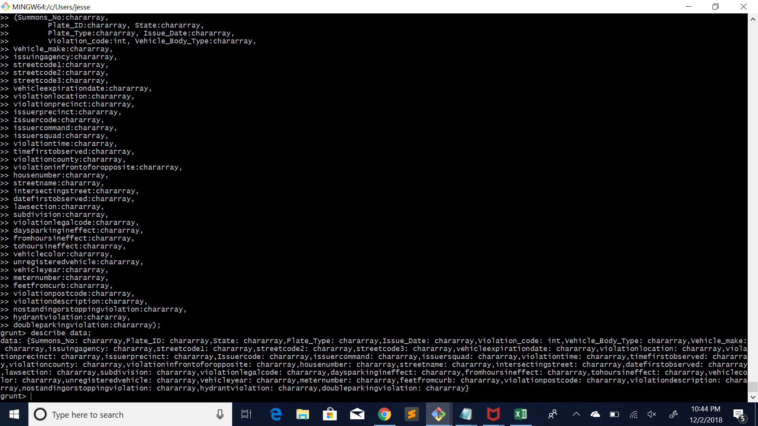

Step 4: Filter data

Now, you need to filter the data in Pig to show only the data necessary to answer the questions.

Some of these fields include the Plate_ID, vehicle_color, etc. This code will make a new record for each record in the ‘data’ table that only contains necessary information.

grunt> stuff = FOREACH data Generate

(Summons_No,

Plate_ID,

State,

Plate_Type,

Issue_Date,

Vehicle_Body_Type,

Vehicle_make,

Vehiclecolor,

Violation_code,

Violationlocation,

Intersectingstreet,

Violationcounty,

Violationtime,

violationdescription);

grunt> DESCRIBE stuff;

After running the code, use DESCRIBE to test that the new data set was created correctly with all necessary fields.

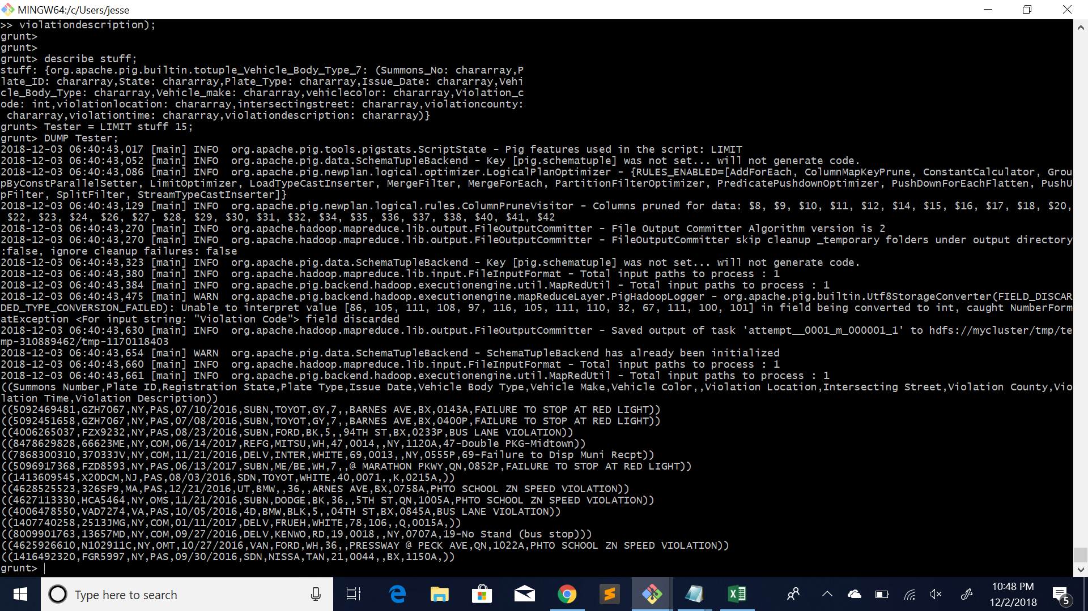

After checking that ‘stuff’ was created correctly with all proper fields, you want to test that the data is formatted correctly. For this reason, you will create ‘Tester’ that will copy a limited number of records from ‘stuff’ by using the LIMIT function. You then DUMP ‘Tester’ to check that the records are following the correct format.

grunt> Tester = LIMIT stuff 15;

grunt> DUMP Tester;



Step 5: Export data

After making sure that the data in ‘stuff’ contains all the necessary data, you want to store ‘stuff’ into the HDFS using the following command.

grunt> STORE stuff INTO ‘tickets_2017.csv’ USING Pigstorage(‘,’);

…

grunt> QUIT;

To make sure that Pig saved the results of the the filtering, you want to find your filename within our HDFS by using the -ls command. Once the file is found, you will want to see if the data is in the directory by using the second -ls command.

$ hdfs dfs -ls

…

$ hdfs dfs -ls tickets_2017.csv

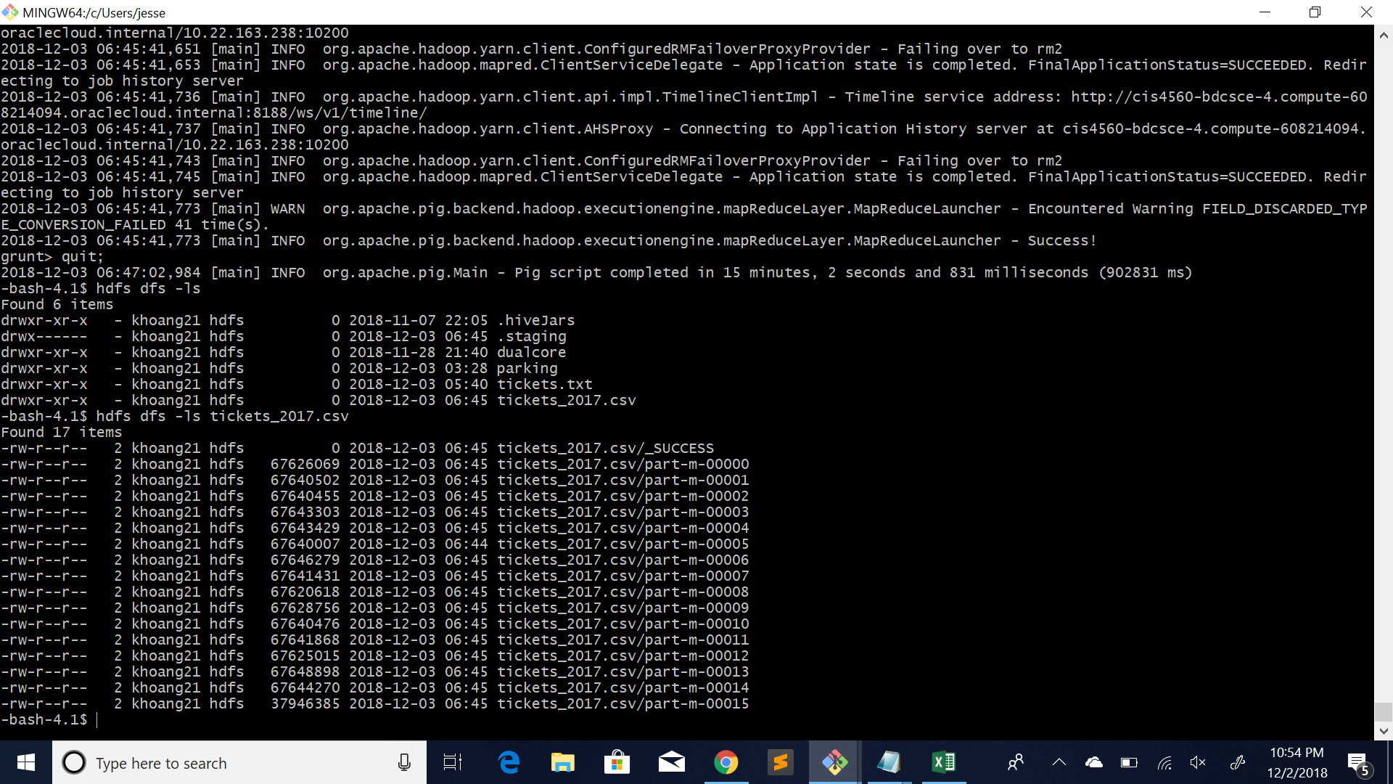

After finding that all the data has been saved as different part files, you want to merge all the data into one complete file of type CSV. After this is done, you will want to check that the file exists on your local file system, so run an ls command.

$ hdfs dfs -cat ./tickets_2017.csv/part* > tick.csv

$ ls

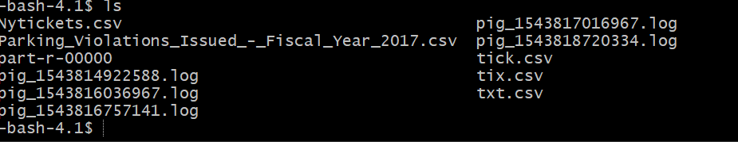

*In a new terminal* Write out the following command to download the tick.csv file and rename it as Nytickets.csv. Make sure to change to your username when writing the command.

$ scp username@129.150.202.0:/home/username/tick.csv Nytickets.csv

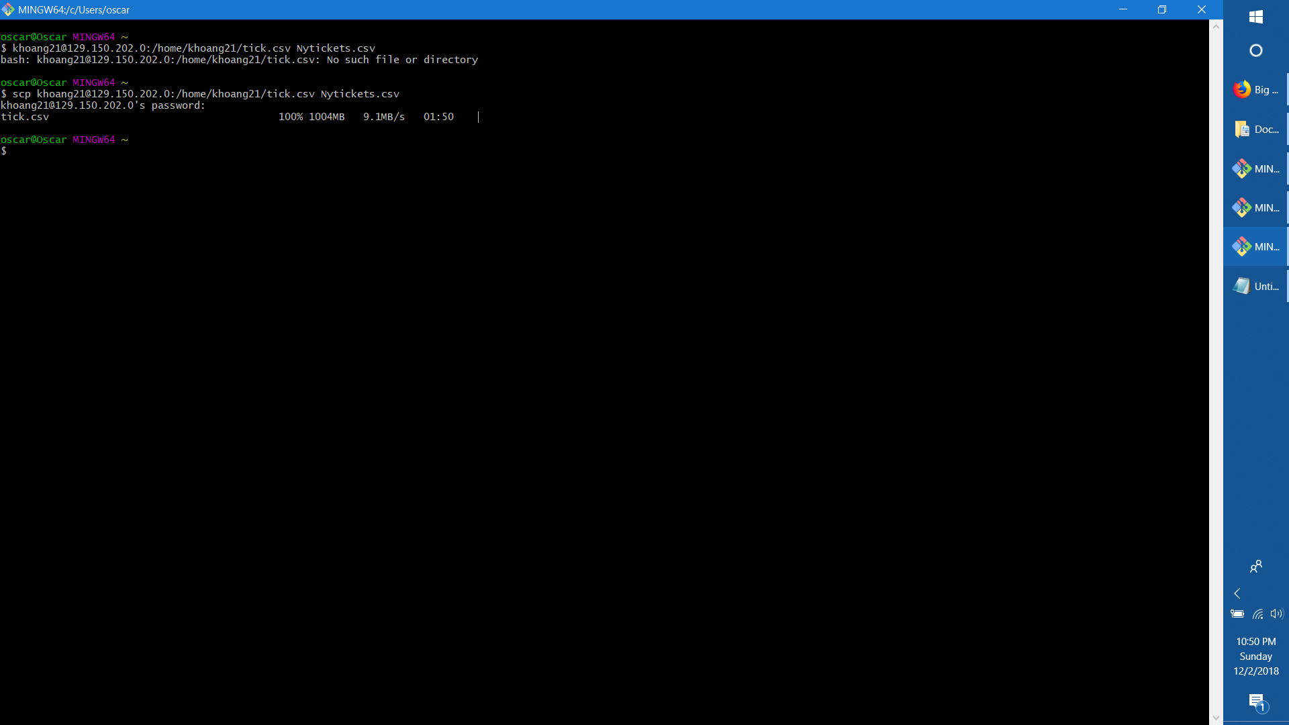

Step 6: Visualize data using Power BI

Open the Power BI app or go to <https://app.powerbi.com> to download the application.

After downloading and installing your application, go ahead and open it.

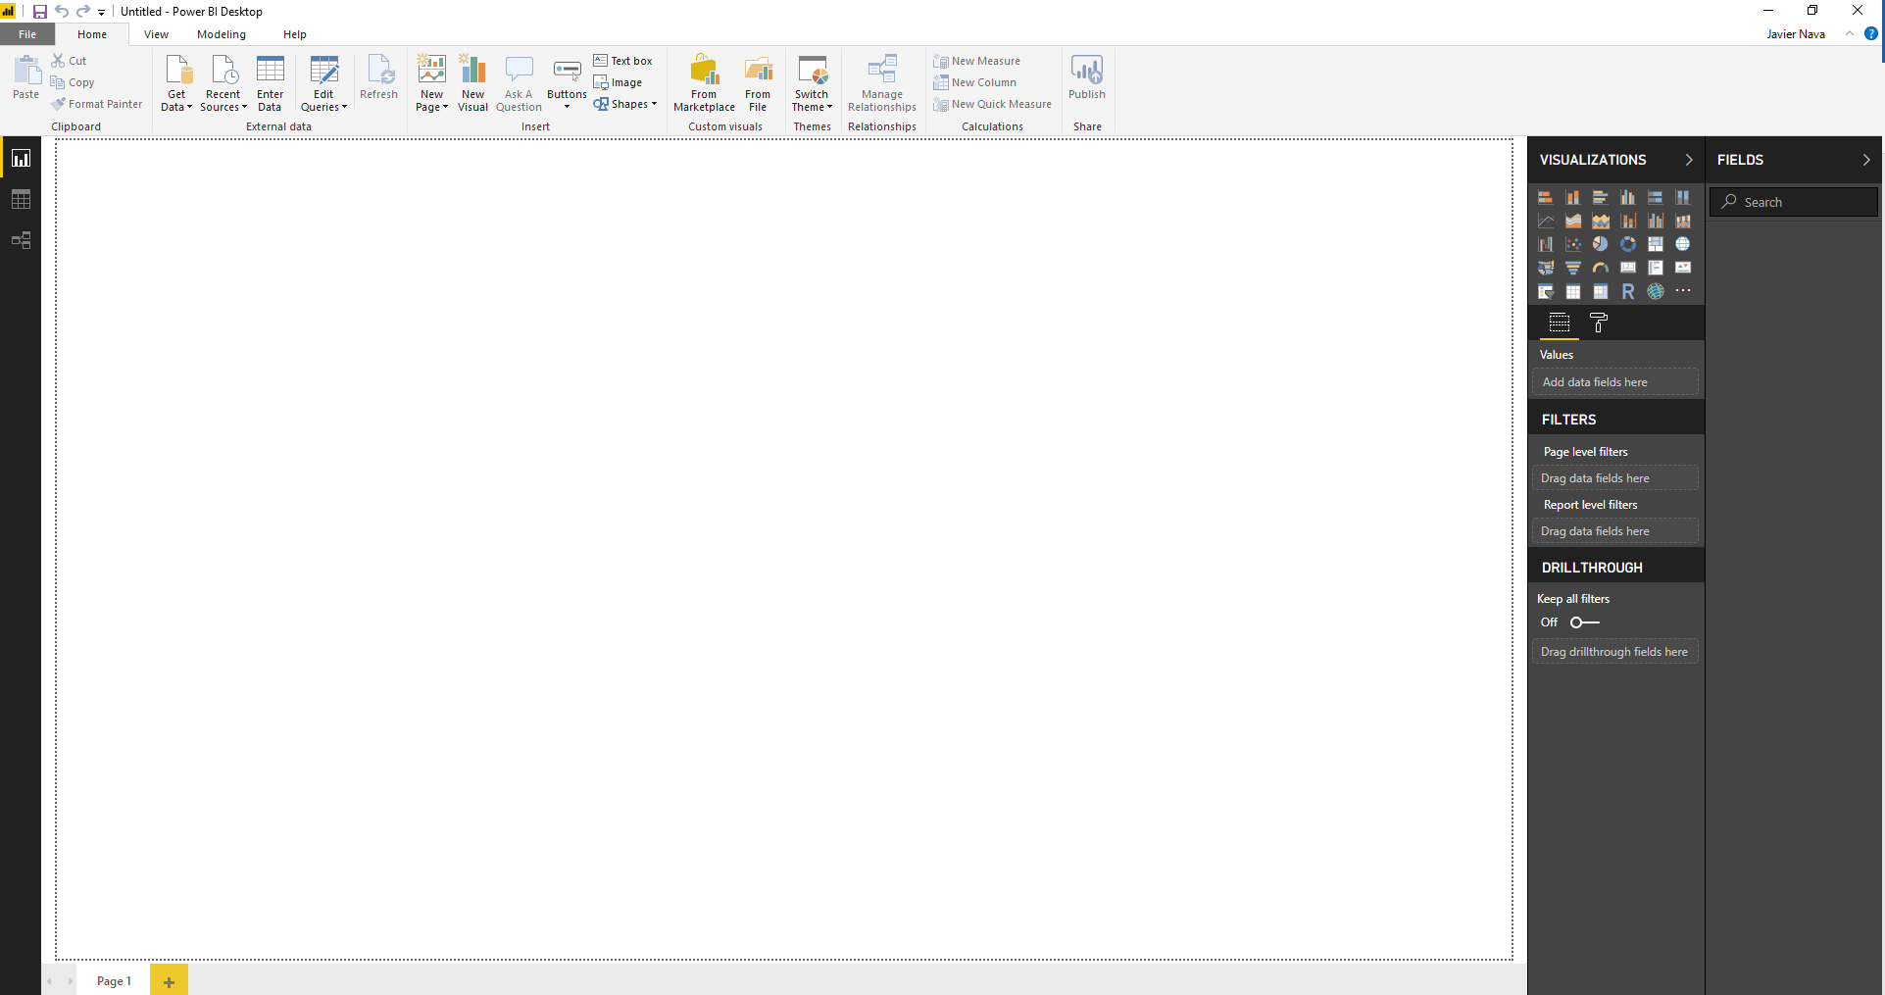  
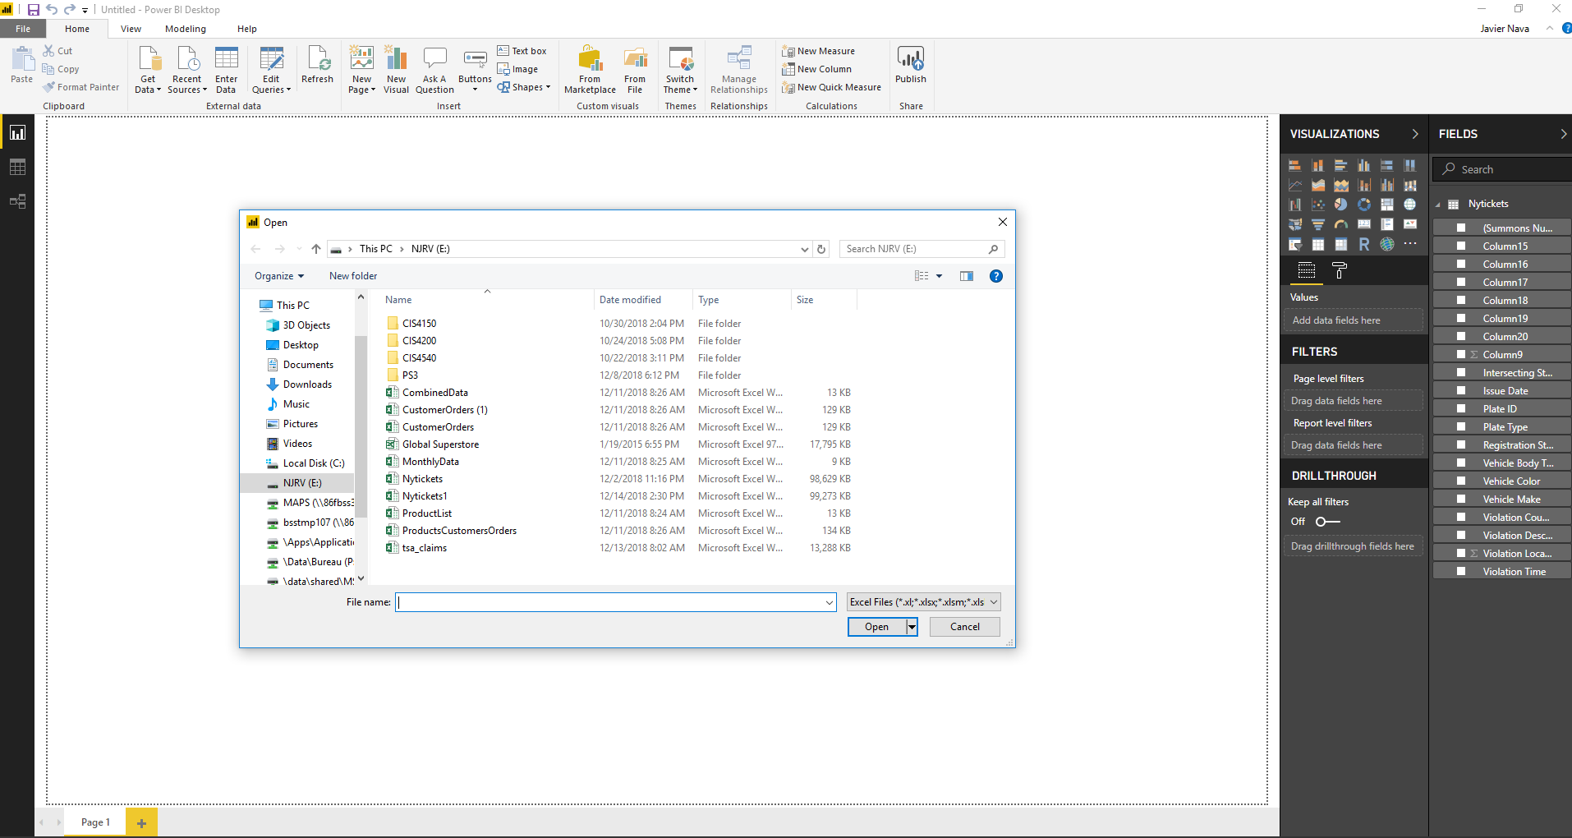

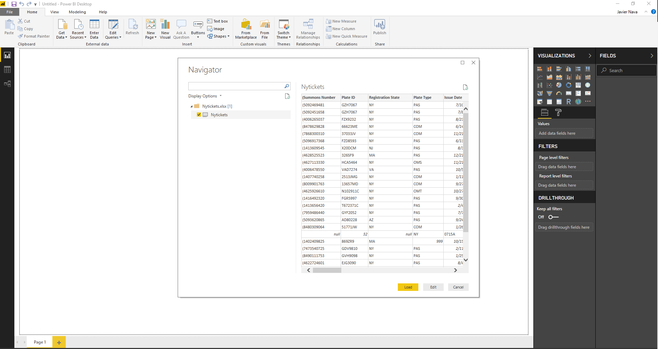

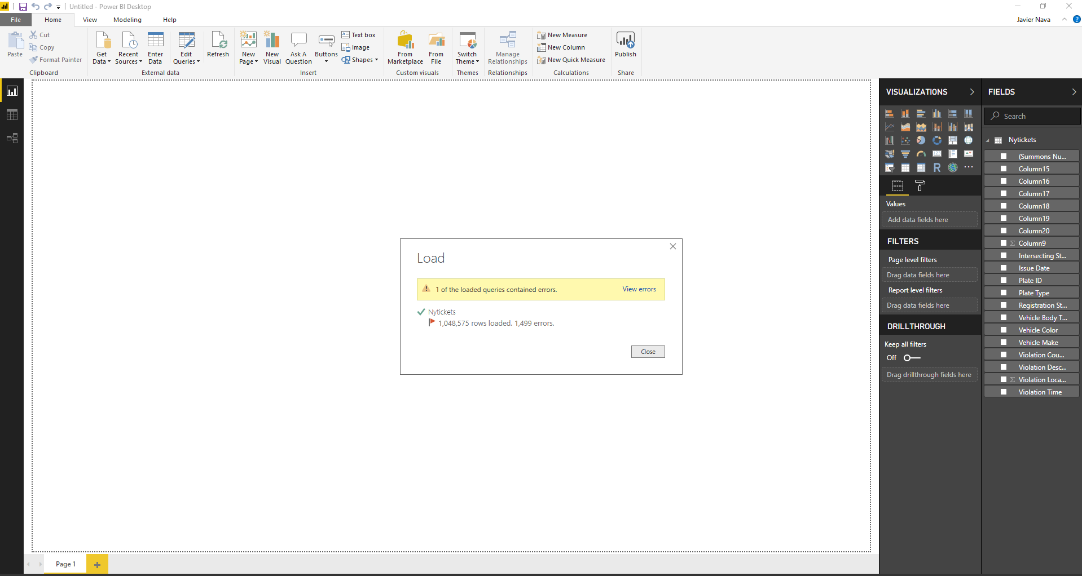

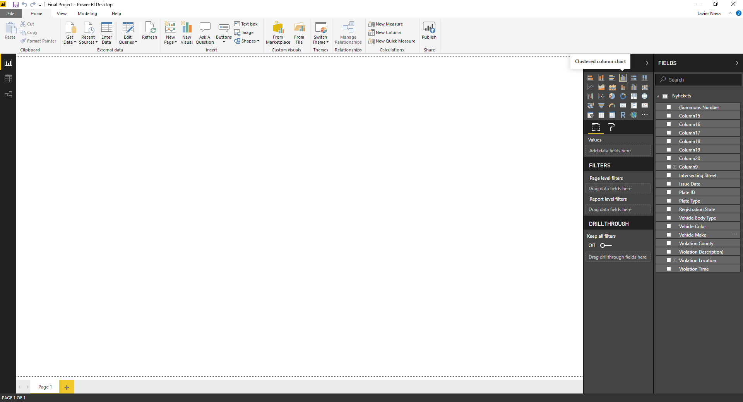

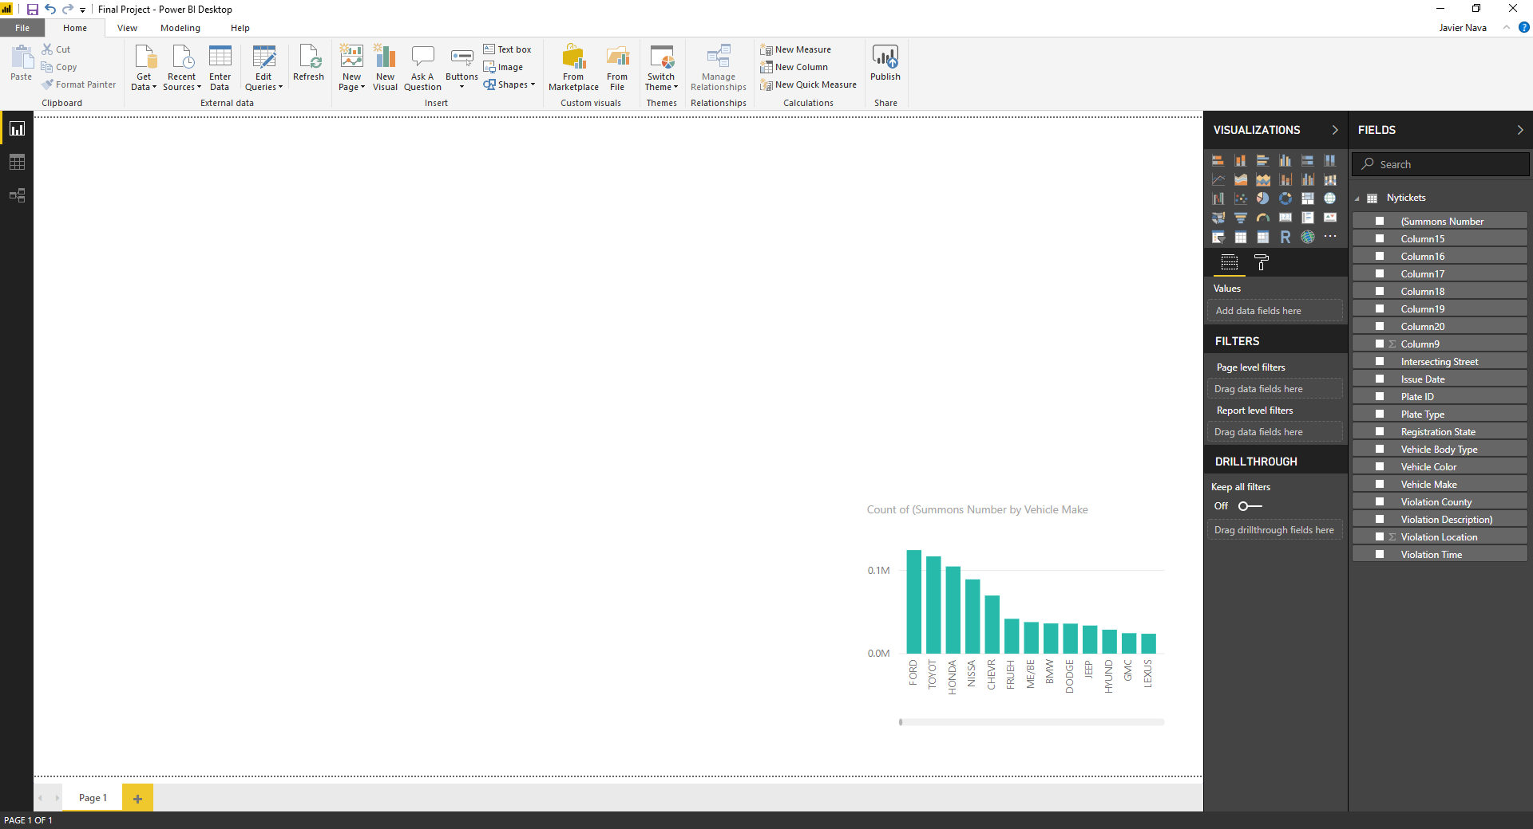

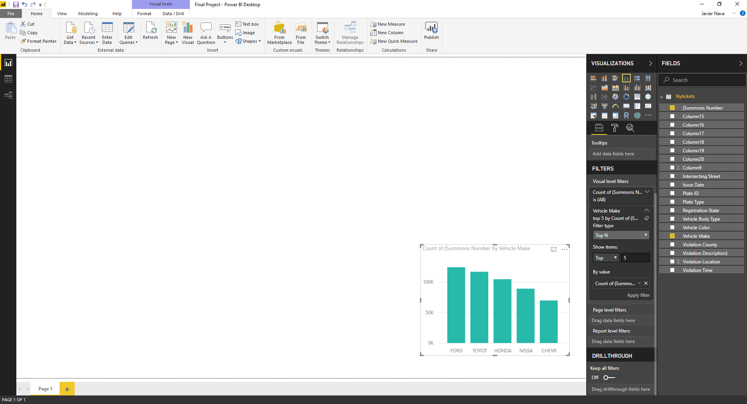

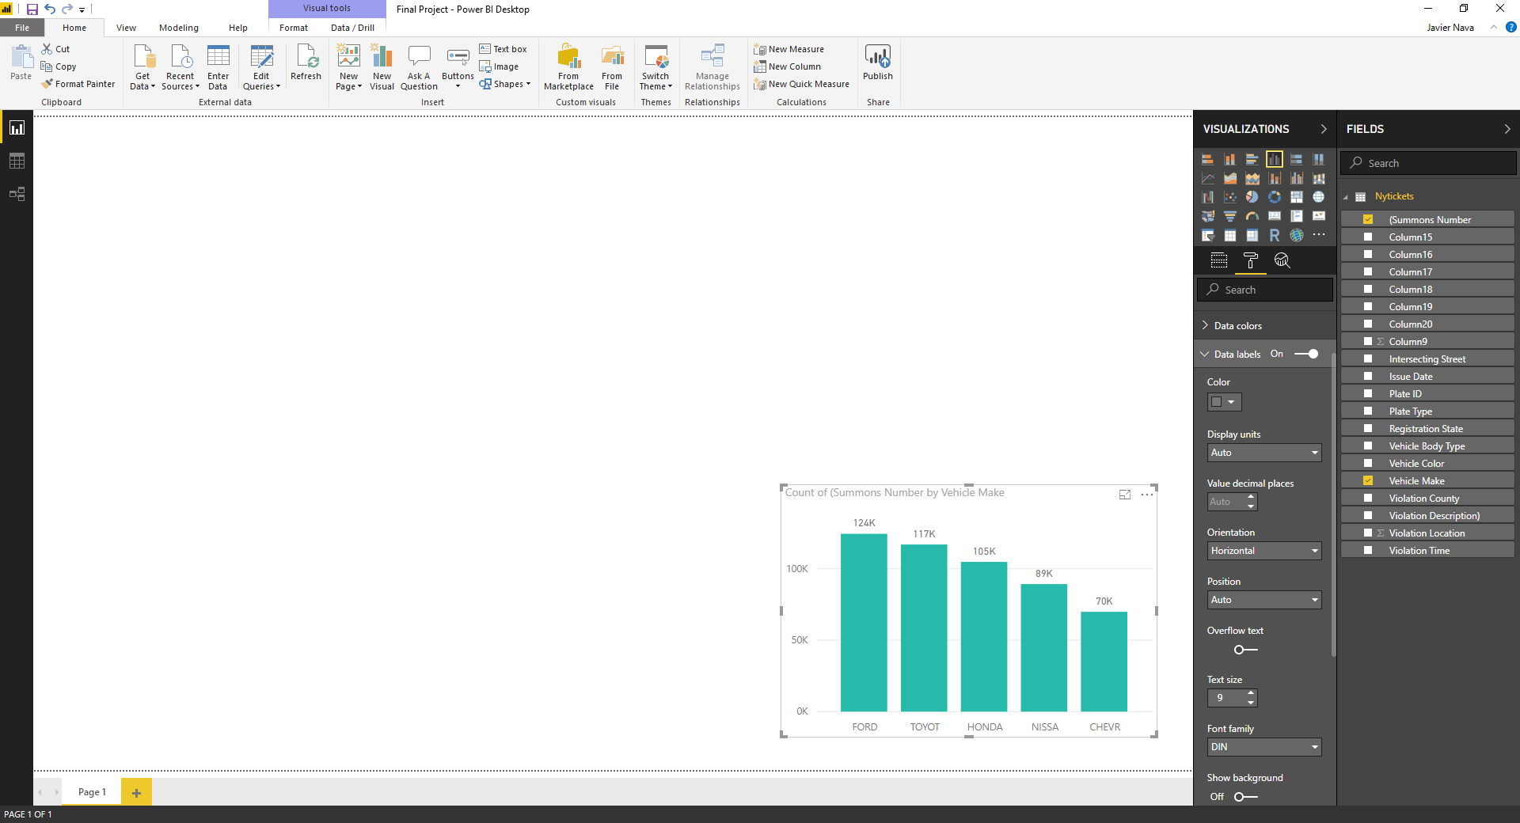

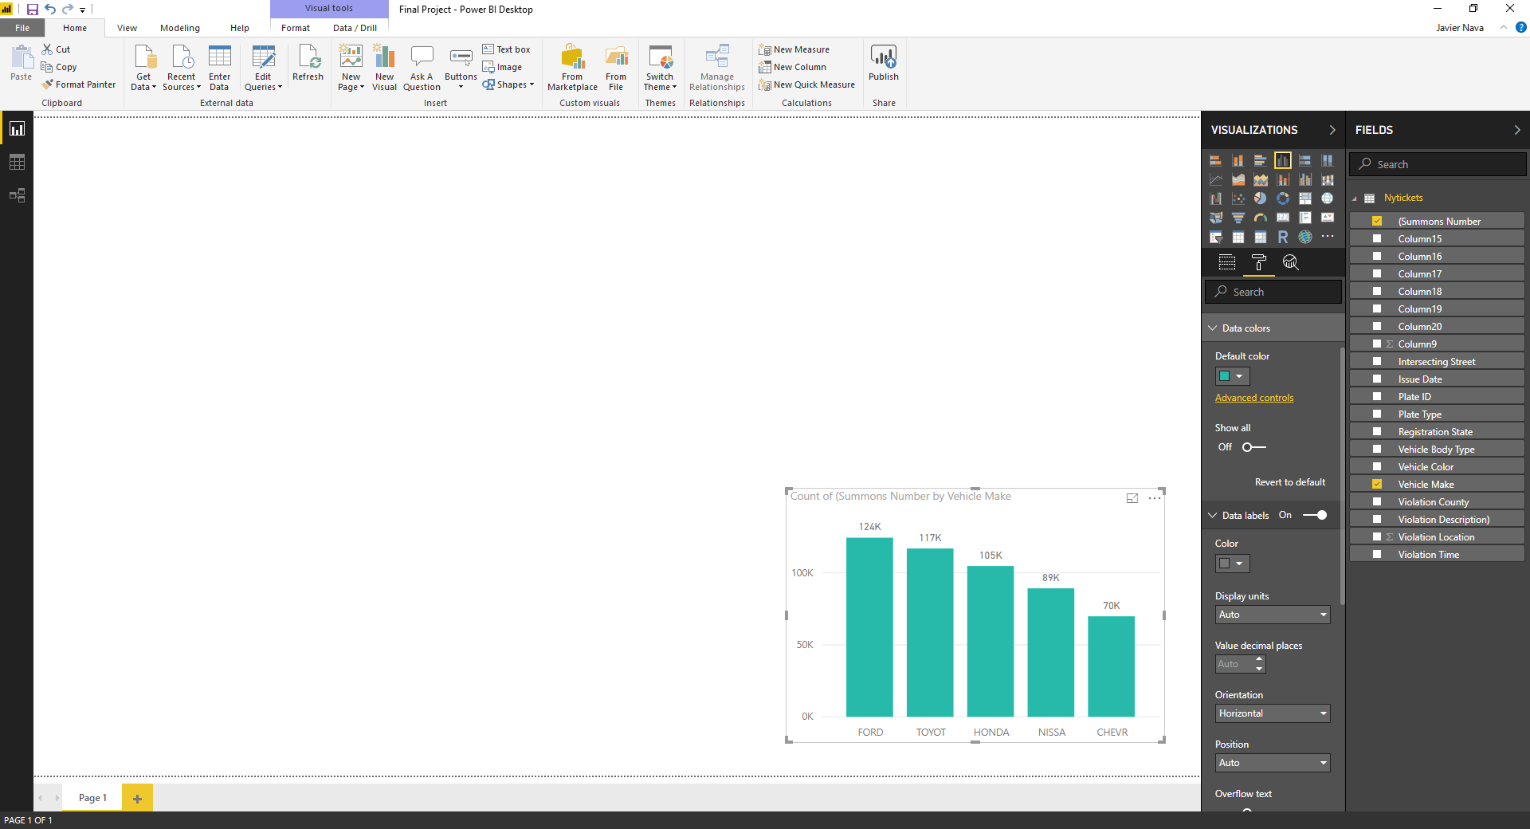

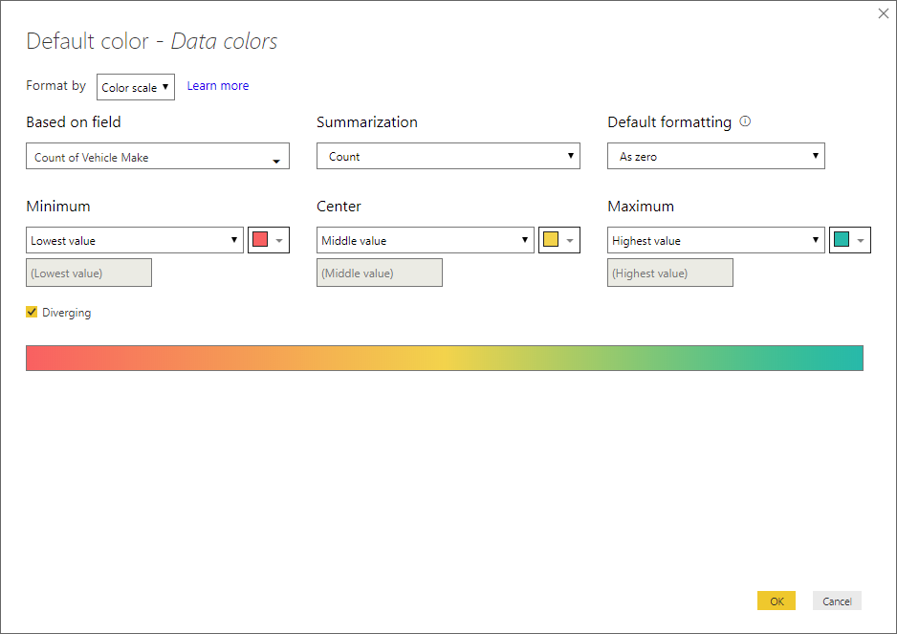

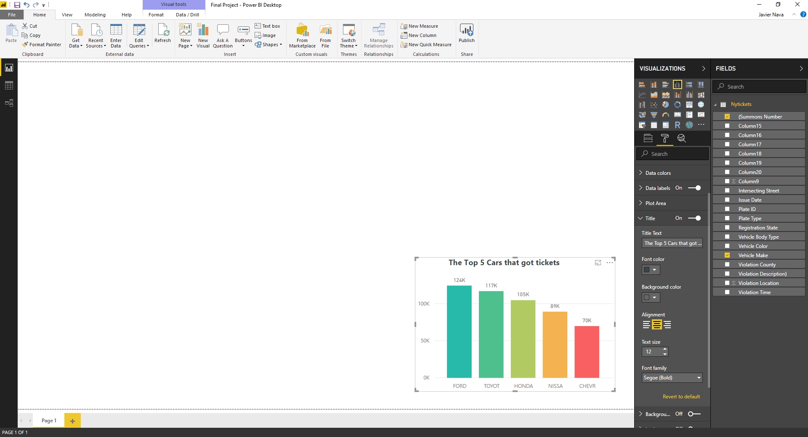

2) Next, we are going to visualize the top 5 car colors attracted the most tickets.

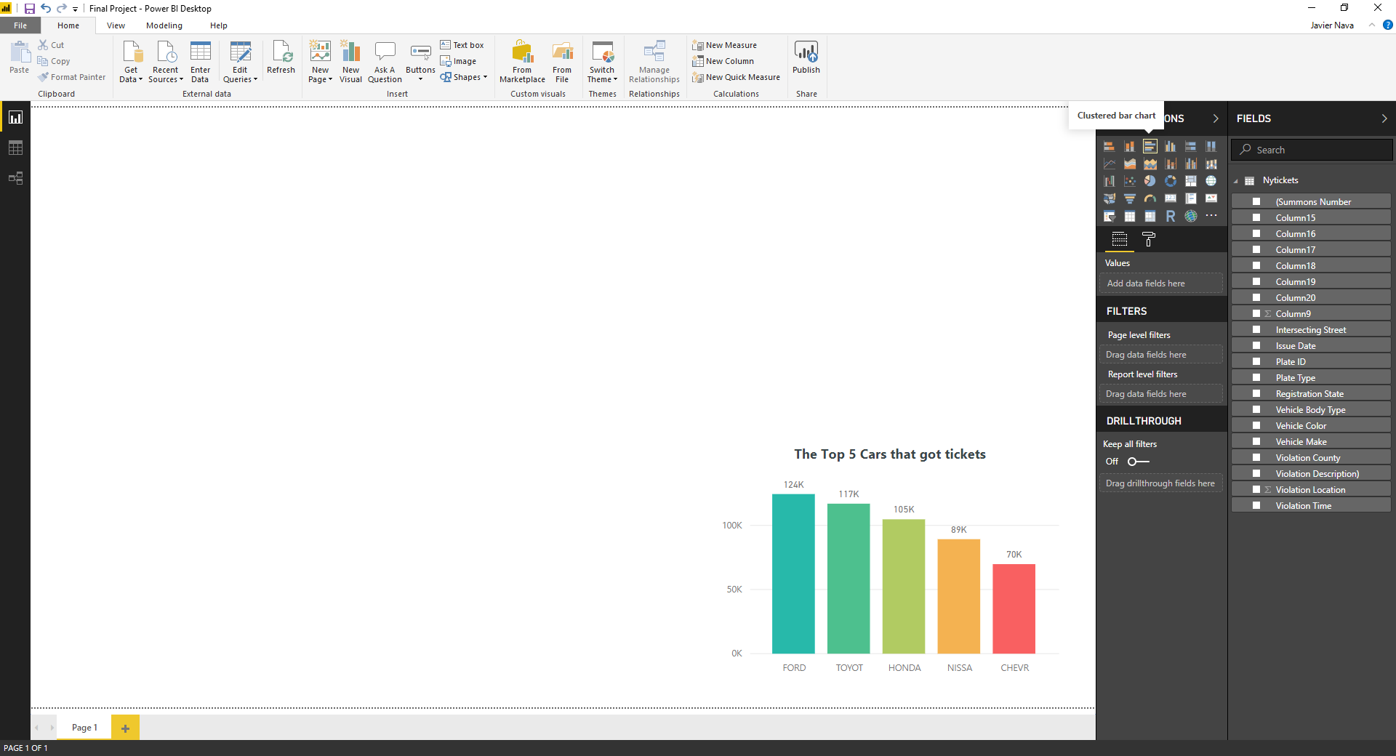

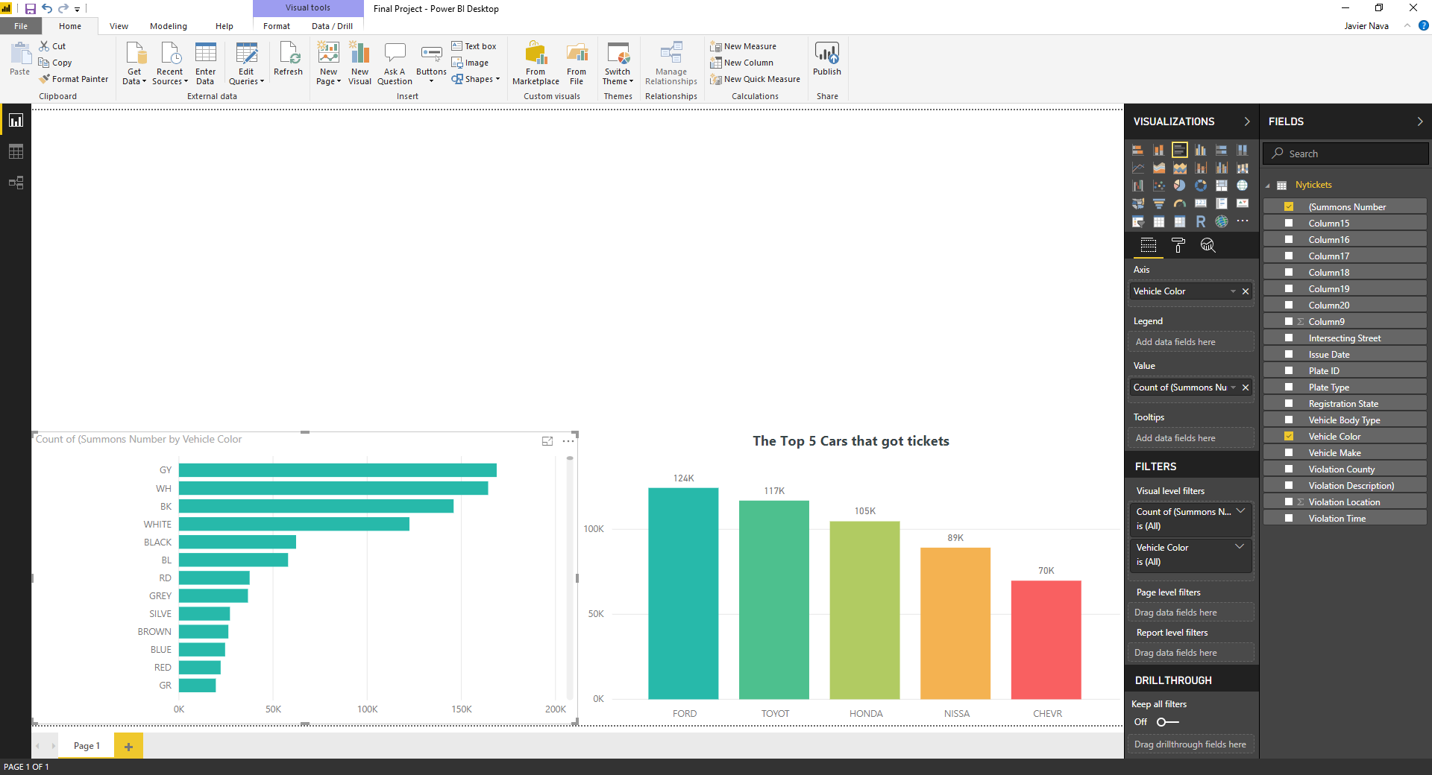

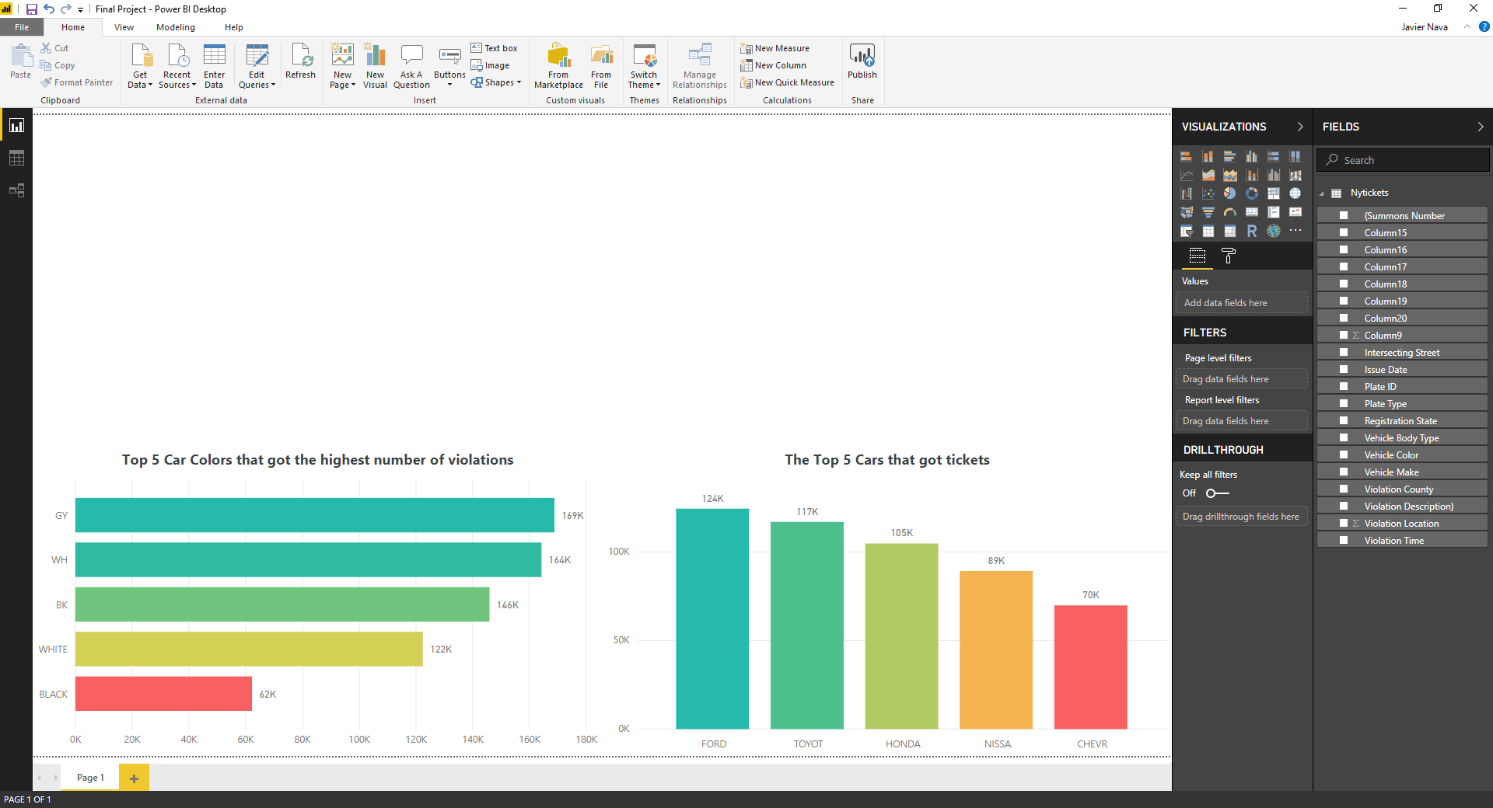

3) We are now going to visualize the states that had the highest number of cars registered that got the highest amount of tickets.

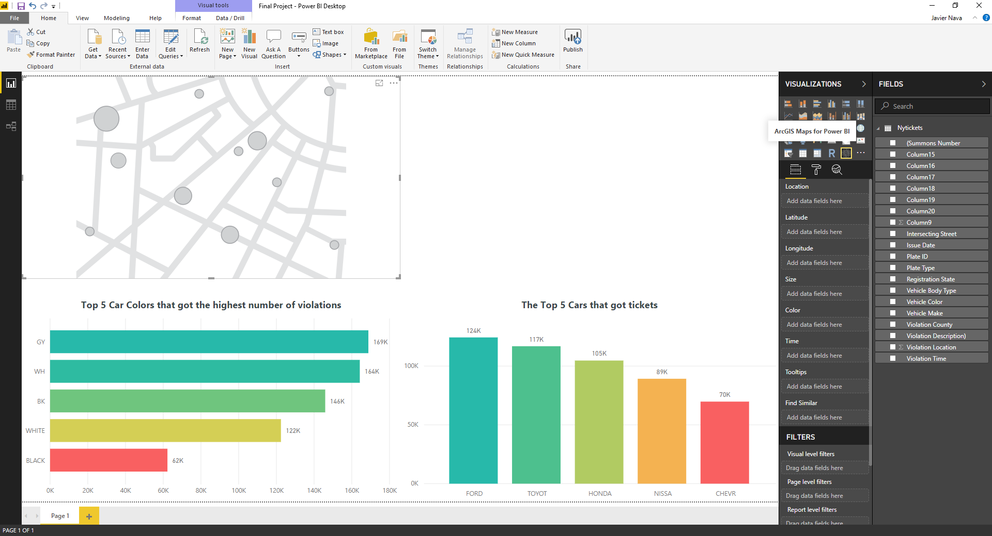

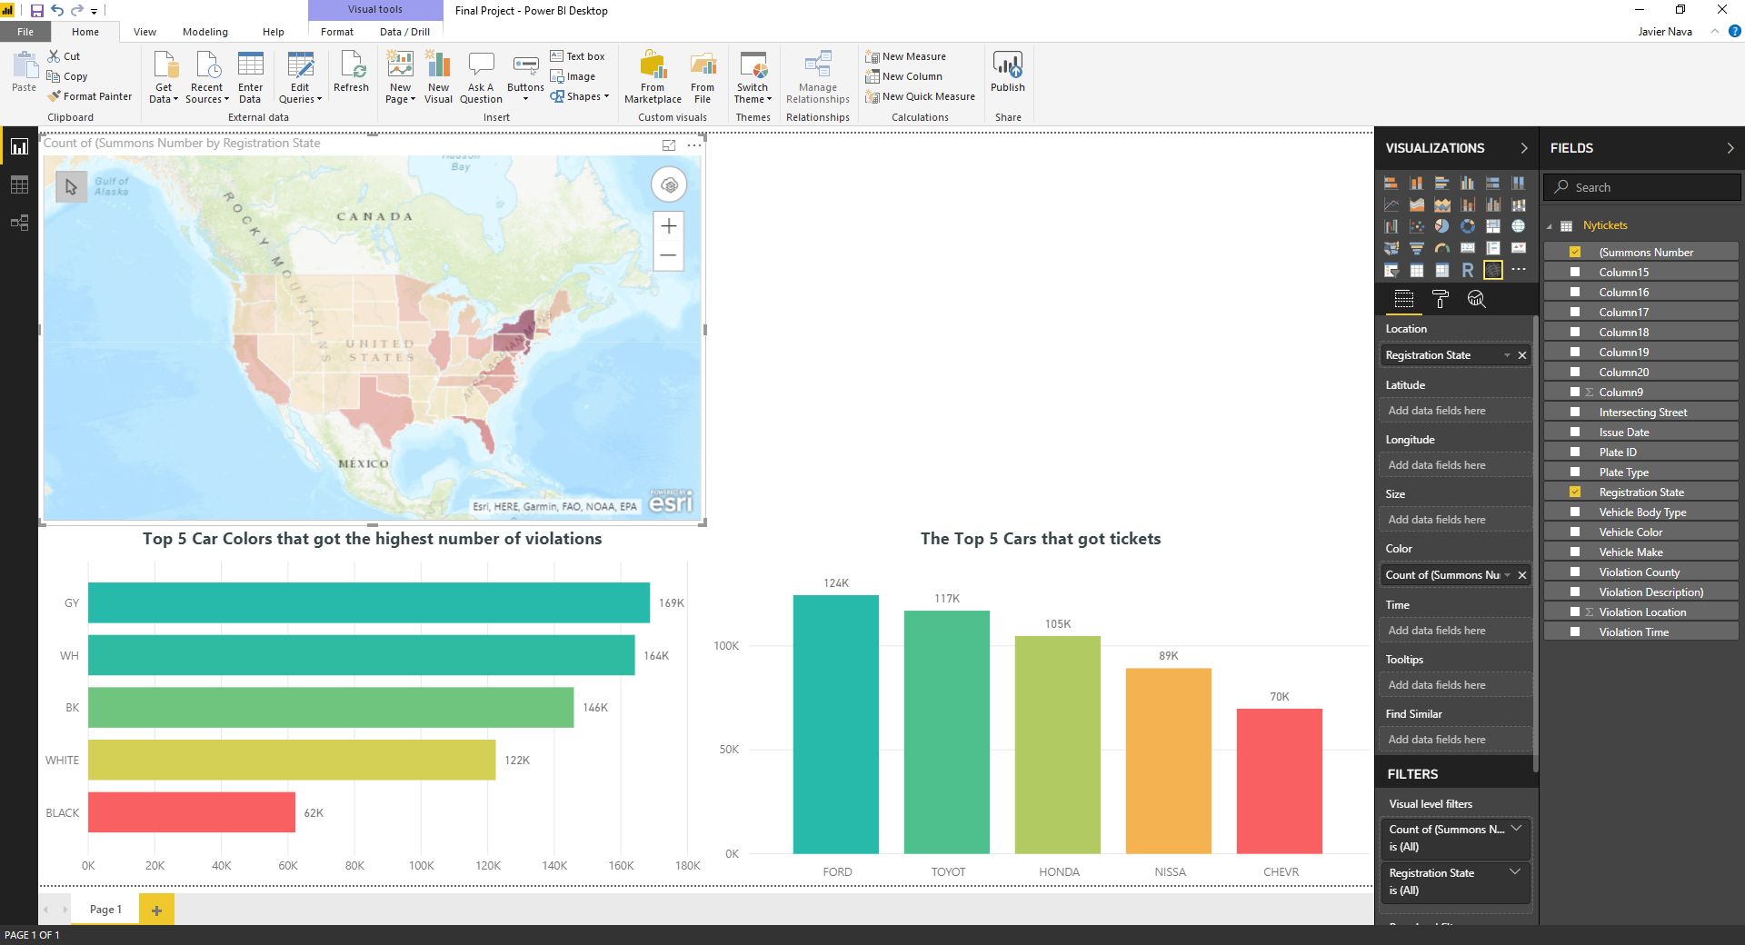

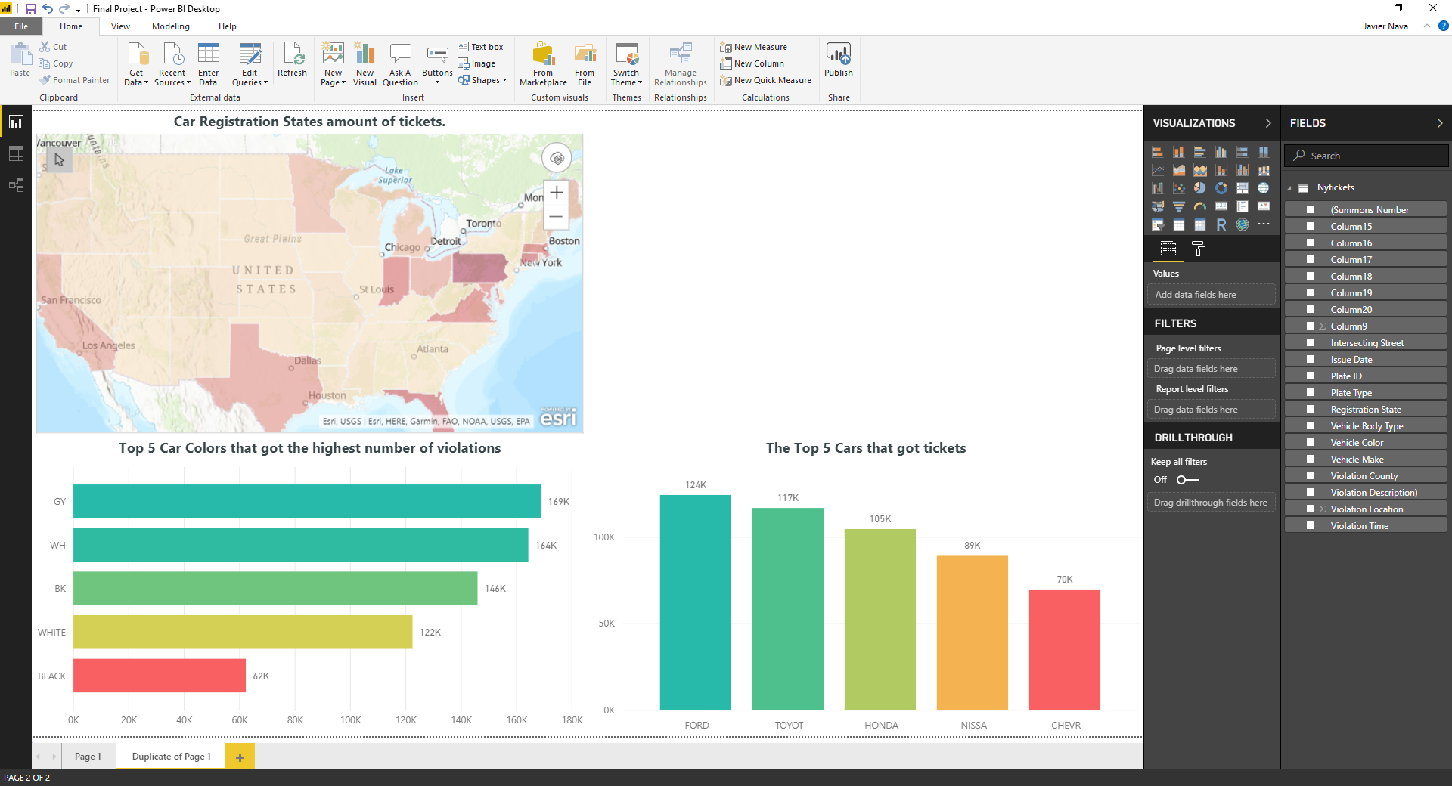

4) Moving forward we are going to visualize the times that had the highest amount of tickets?

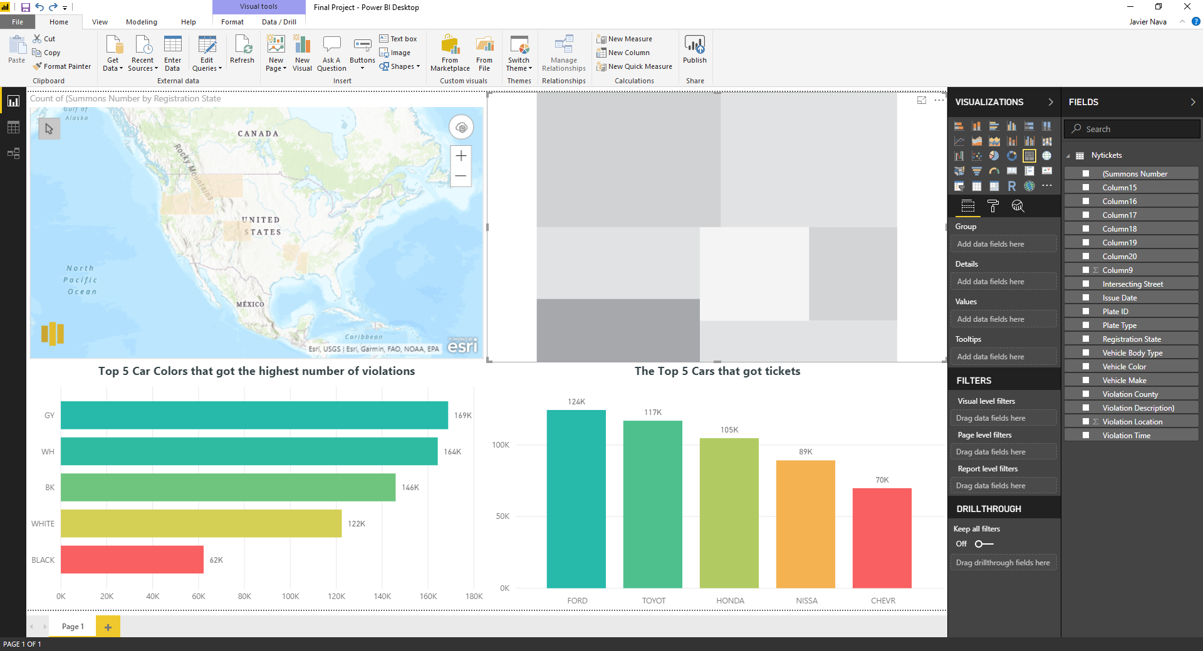

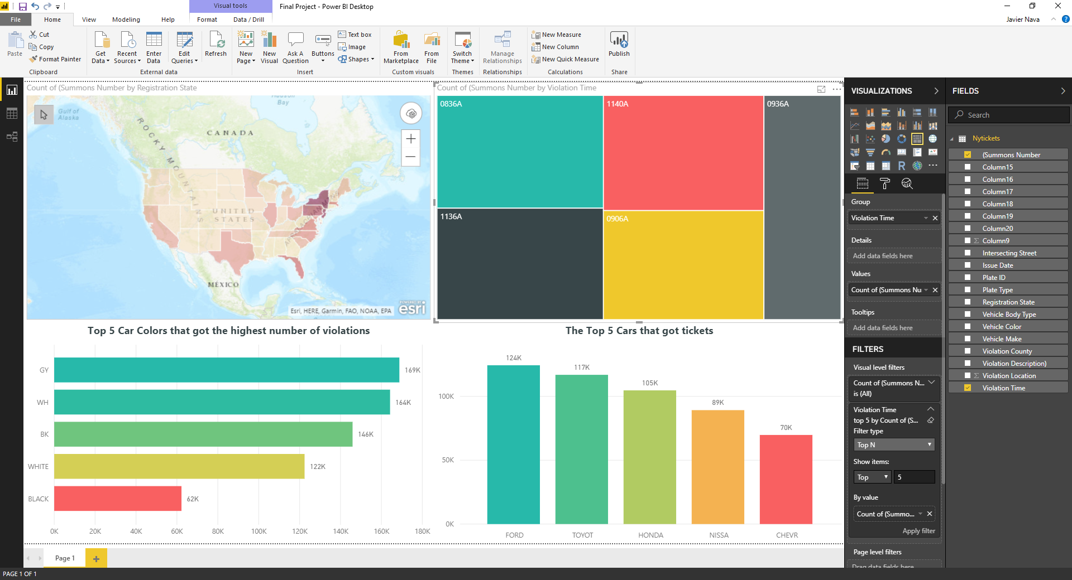

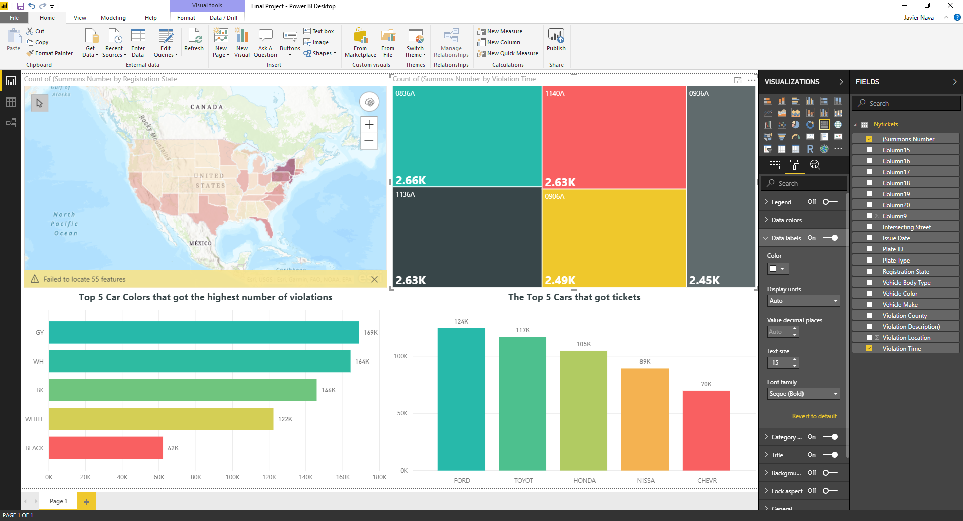

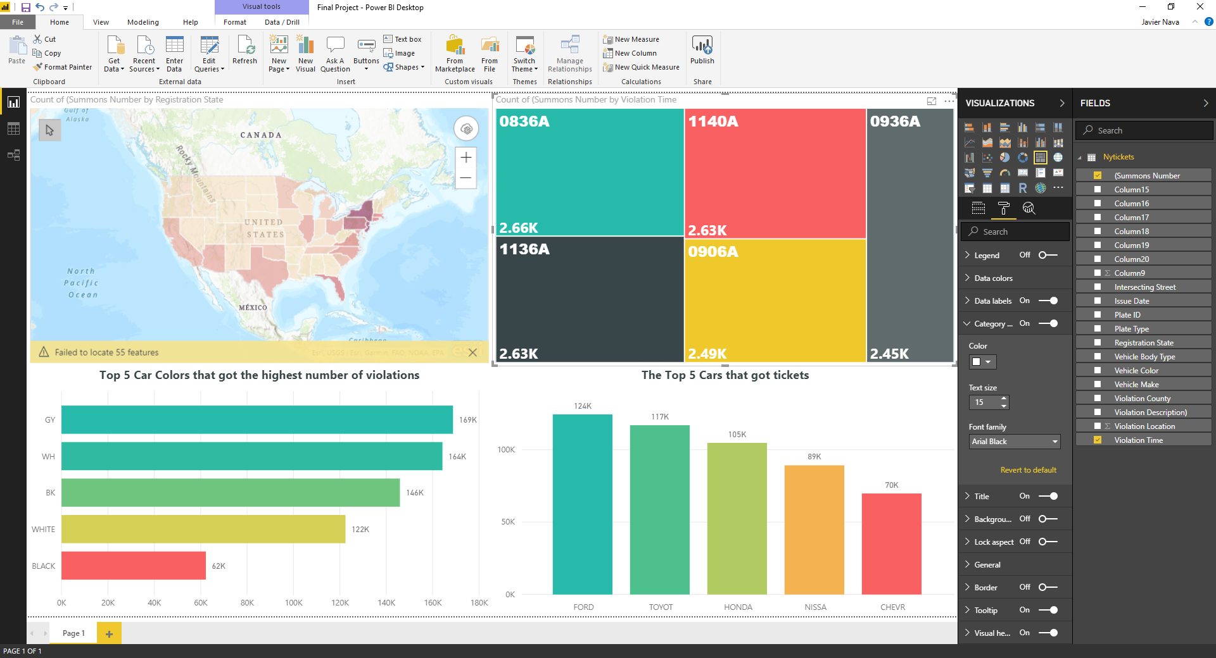

5)

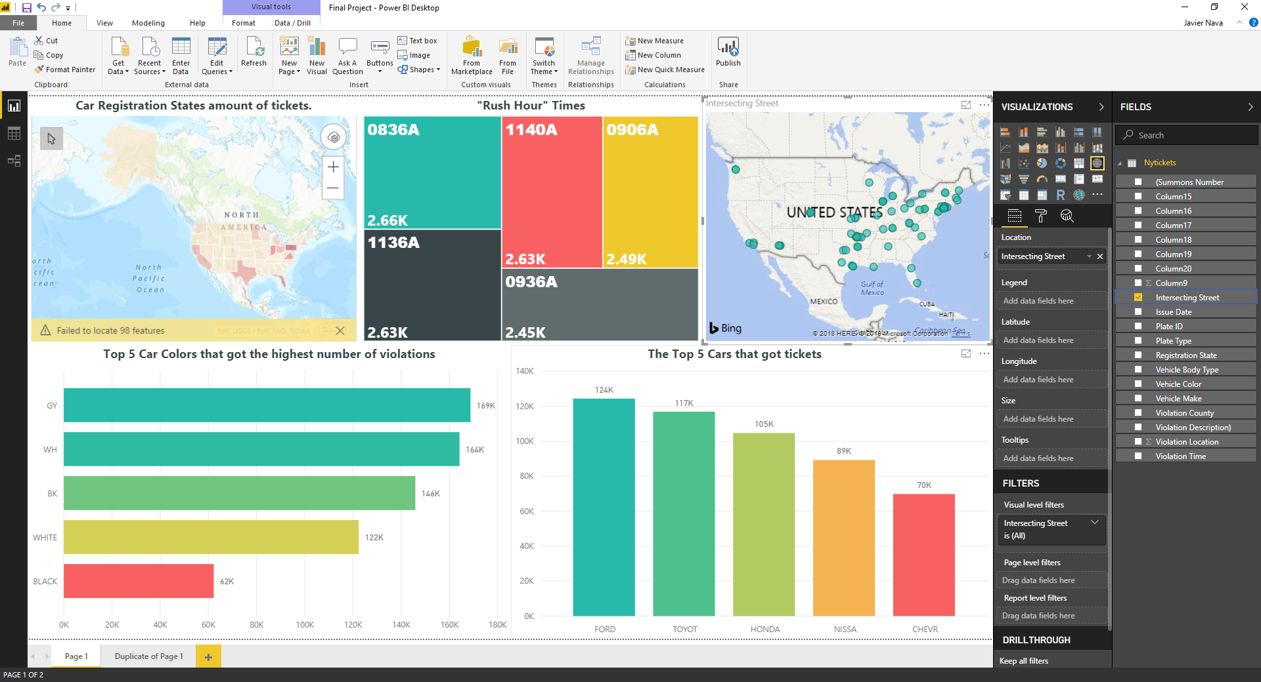

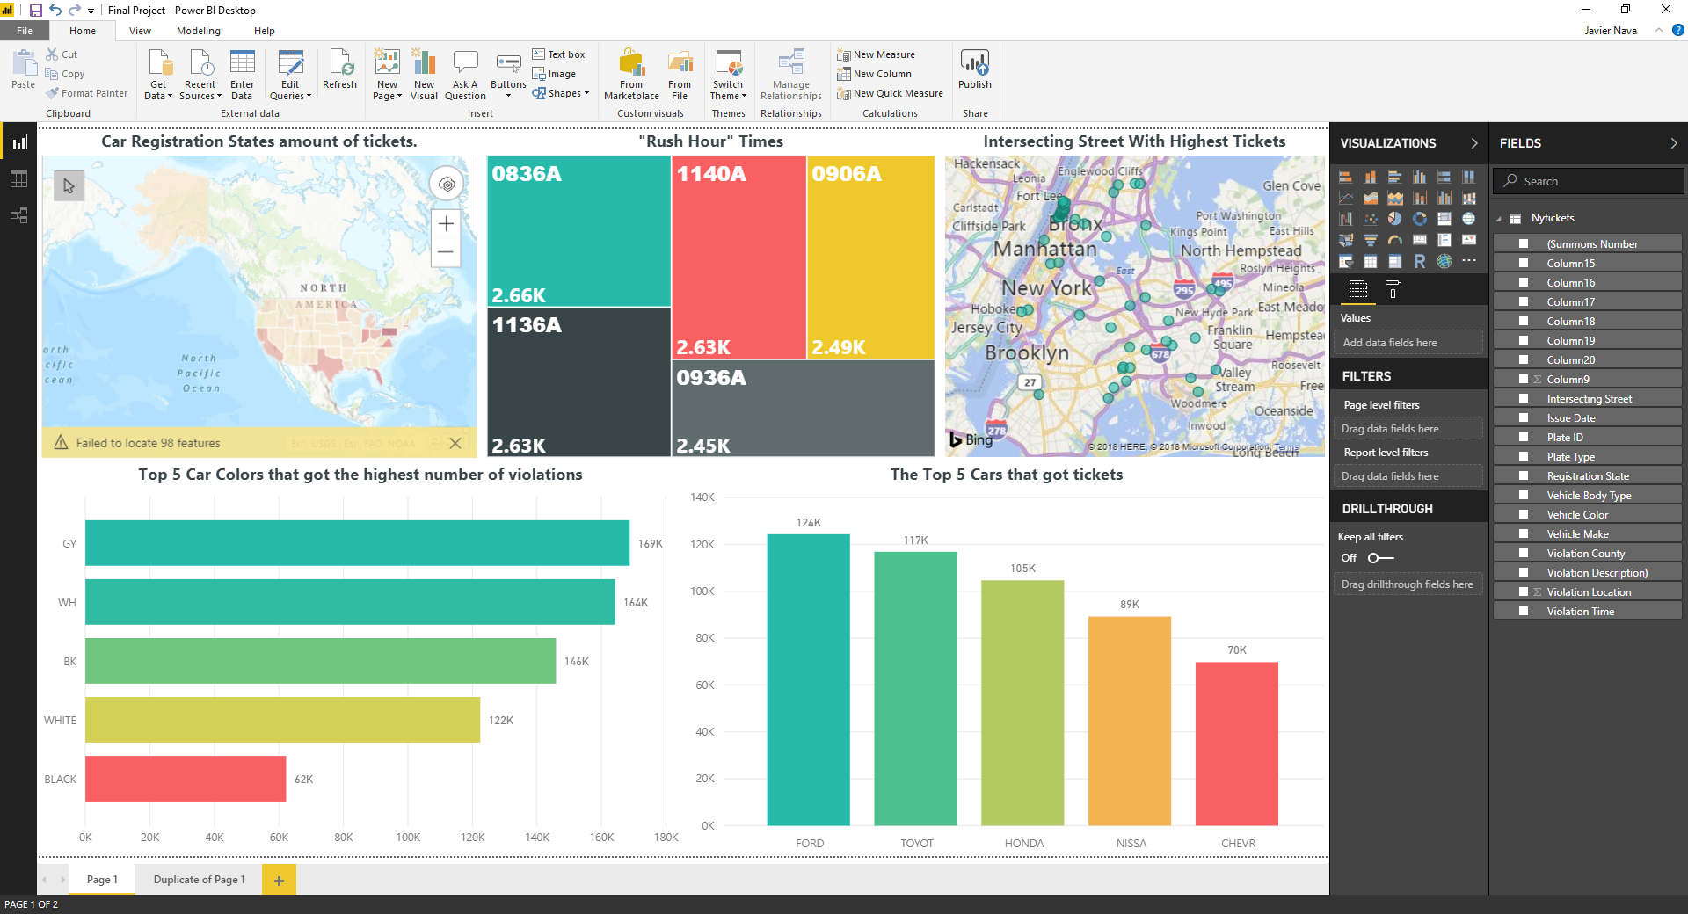

Conclusion

In this tutorial, we learned how to create an alias using pig, extract useful information from a dataset, and how to export the alias into a CSV file. We then downloaded the new dataset to our local computer then used Power BI to analyze and visualize the data to answer our questions.

References

1. <https://data.ny.gov/api/assets/83055271-29A6-4ED4-9374-E159F30DB5AE>
2. <https://www.kaggle.com/new-york-city/nyc-parking-tickets#Parking_Violations_Issued_-_Fiscal_Year_2017.csv>
3. <https://github.com/oscarmnz8/Big-Data-NYC-Parking-Tickets>